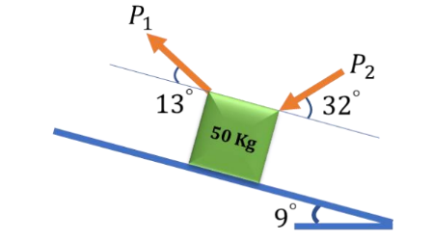1.

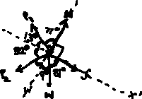

**N – Normal force exerted on the block by the inclined plane**

**f – Frictional force (Static or Kinetic)**

**w – Weight of the body = 50x9.8 = 490N**

Resolving forces along XX’ direction (taking forces in XX’ direction as positive):

**FXX’ = f + wcos(81°) – P1cos(13°) – P2cos(32°) 🡪 Eqn.1**

Resolving forces along YY’ direction (taking forces in YY’ direction as positive):

**FYY’ =wcos(9°) + P2cos(58°) – P1cos(77°) – N 🡪 Eqn.2**

1. Equations of Force equilibrium:

NOTE: Friction is static 🡪 f =μs­N = 0.8N

P1 = 2P2

FXX’ = 0: 0.8N + 490x0.156 – (2P2)x0.974 – (P2)x0.848 = 0

**0.8N + 76.653 = 2.797P2 🡪 Eqn.3 (From Eqn.1)**

FYY’= 0: 490x0.987 + 0.53P2 – (2x0.225)P2 – N = 0

**483.967 + 0.08P2 = N 🡪 Eqn.4 (From Eqn.2)**

1. To get P2, we need to solve Eqn.3 and Eqn.4

**Eqn.3 + (0.8)xEqn.4:**

0.8N + 76.653 + 387.174 + 0.064P2 = 2.797P2 + 0.8N



**P2 = 169.713N**

**∴P1 = 2P2 = 339.427N**

1. The maximum force of friction is the static friction = 0.8N

We need to solve for N:

0.8N + 76.653 = 2.797x169.713

**fmax = 0.8N = 398.034N**



f (398.034, μs)

(298.53, μk)

Mgsin9 P

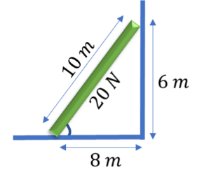

2.

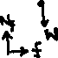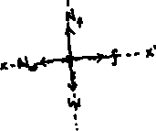

**NW = Reaction force by the ladder by the wall**

**Nf = Reaction force on the ladder by the floor**

**f = Frictional force on the floor**

**w = Weight of body = 20N**

1. **FXX’= 0: f – Nw = 0** 🡪 **Eqn.1**

**FYY’= 0: Nf – w = 0 🡪 Eqn.2**

1. We know moment about A is also 0:

MA = 0: (Nw)x(6) – (w)x(8/2) = 0

**Nw = 2w/3 = 40/3 = 13.33N 🡪 Result.1**

**Nf = w = 20N** (From Eqn.2)

f = Nw = 13.33N (From Result.1)

1. We know the maximum frictional force is the limiting static friction = 13.33N